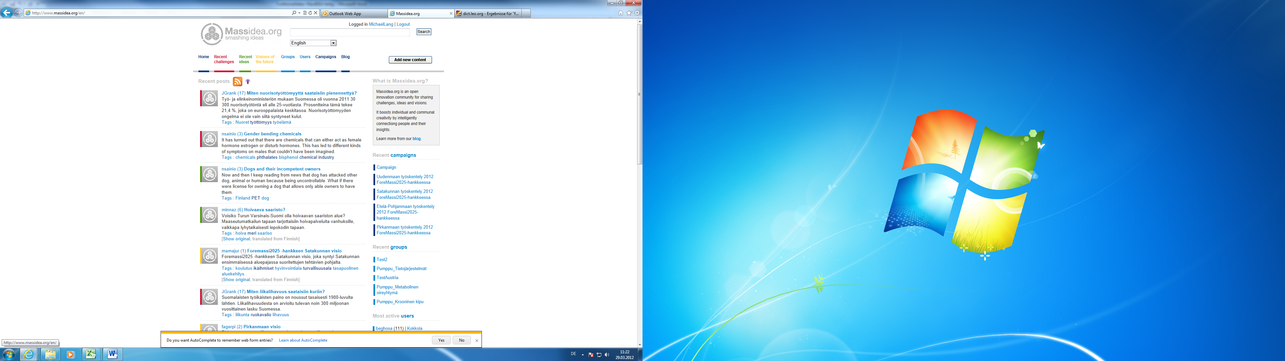

System Requirements

User Experience

Start page 4

Introduction 4

Linked Pages 4

Logo 5

Login 6

Challenges, Ideas, Visions 7

Live Feed 10

Introduction 11

Featured Post 11

Project and Groups looking for new people 12

Footer 12

Creating new content 13

Main page 14

Introduction 14

Linked pages: 14

Header 15

Create new content/group/project 16

Create new content form 17

Sidebar 19

Feed 21

Content Page 22

Introduction 22

Linked pages: 22

Design Concepts 23

Rating 25

Profile/ Profile Settings / Private Messages 26

Profile 26

Profile Settings 26

Private Messages 26

Create Group form 27

Introduction 27

Visibility of the Group 27

Group Page 27

Introduction 27

Create Project form 28

Introduction 28

Project Page 28

Introduction 28

Privacy 29

Introduction 29

Content 29

Group / Project 29

Linking 29

Other useful aspects 30

Text-Fields 30

Comments 30

Administration 30

Group/Project Admin 30

# Start page

## Introduction

The start page should attract potential user’s attention. By clicking through the page, they get a deeper insight into the platform and are able to view contents. Interesting images and animations motivate users to contribute immediately.

Furthermore, users want to see a living platform. This is achieved by showing live feeds, projects looking for people and movement in an introductory video. The main idea of the start page is to create a desire to join the community.

Therefore, the start page follows the AIDA principle:

A - Attention attract the attention of the customer.

I - Interest raise customer interest by focusing on and demonstrating advantages and benefits (instead of focusing on features, as in traditional advertising).

D - Desire convince customers that they want and desire the product or service and that it will satisfy their needs.

A - Action lead customers towards taking action and/or purchasing.

Those four topics are addressed by several elements on the page described below. Because the final arrangement of all elements is flexible, the wireframes of the user experience study were designed separately for a modular assembly system.

## Linked Pages

* Project Page
* Content List Page (the whole content is listed of either a challenge, idea or vision)
* Content Page
* Create new content form

## Logo

### Functional Description

The logo of MassIdea always refers to the start page and is a central anchor to come back to an initial point at any state. When logged in, the logo refers to the main page.

### Design Concepts

The logo can either be displayed left or centered in the header, whereas there are multiple options:

#### **Option 1: Connected Logo**

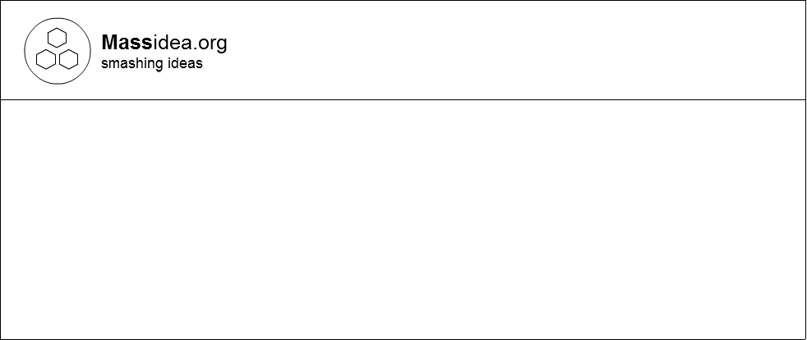

The logo and Massidea.org lettering are connected and shown side by side. This is the easiest, but probably also most conservative approach.

#### **Option 2: Connected and breaking the box**

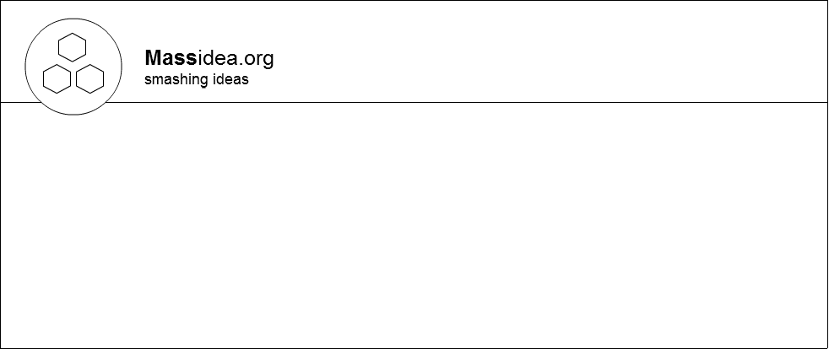

Breaking the box is a modern design approach for creating outstanding and fresh layouts. By overlapping the logo, the user’s eyes focus on it and identify it as a central hub to get back to the start page from everywhere.

#### **Option 3: Separated and breaking the box**

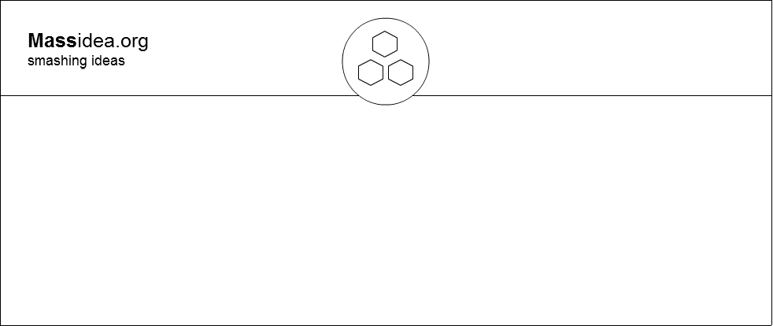

Separating the logo allows further flexibility when designing the header. Furthermore a symmetrical look is created and the importance of the logo as a central hub is enhanced once again.

## Login

### Functional Description

The login form is positioned in the page header and contains email and password fields, as well as a link for signing-up. As logging in is one of the first steps in the standard workflow of typical users, it is important to reach the login form quickly.

The sign-up process is triggered by clicking on the according link, which launches a modal dialog window and shows a sign up form. For more information, see the signing up chapter.

### Design Concepts

#### **Option 1: Placeholder labels**

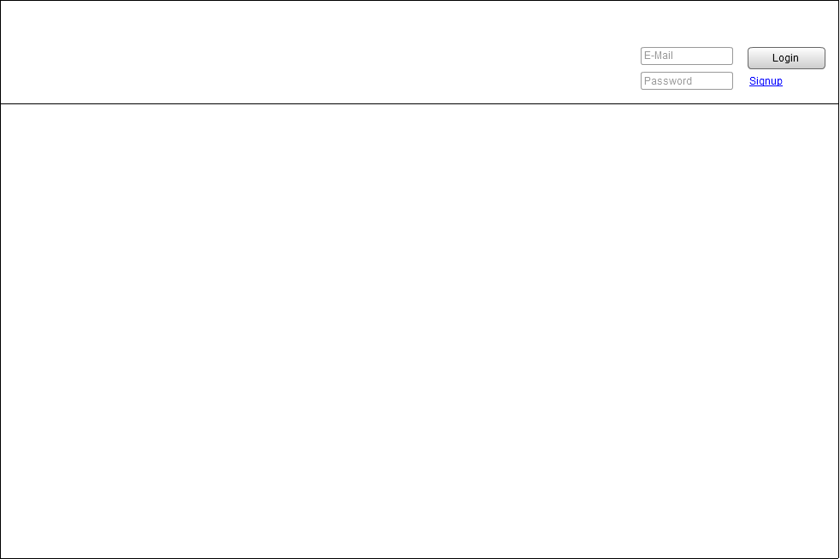

#### **Option 2: Separate lables**

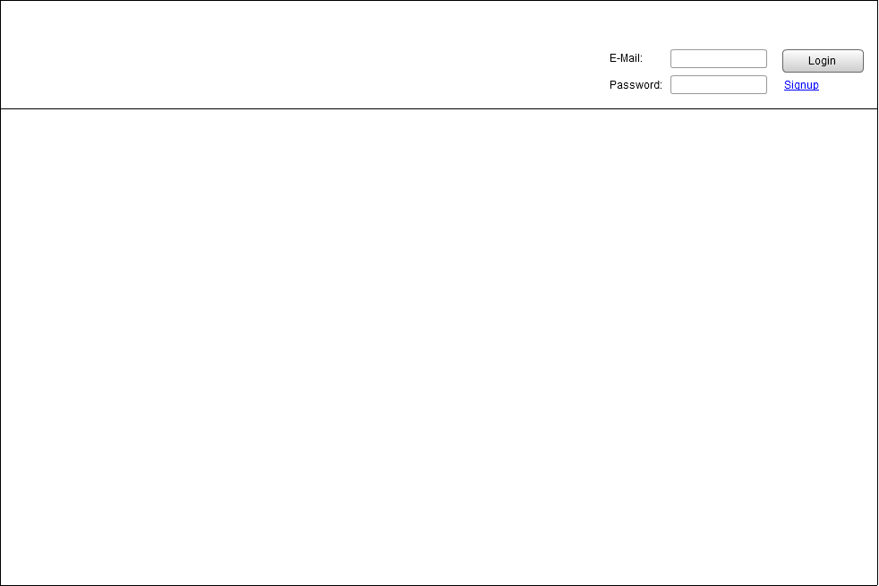

The advantages of those two concepts clearly are the ease of access and support of the standard workflow of a user who enters the site and want’s to access content. However, much space is needed to display the form, for what reason another concept shows how the login form could collapse and slide down:

#### **Option 3: Slide down form**

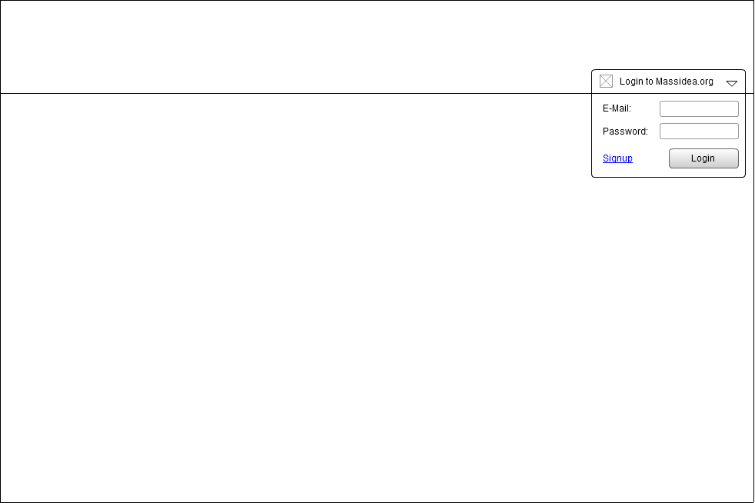

## Challenges, Ideas, Visions

### Functional Description

It is the main feature of the start page to inform visitors about the key sections and ways of broadcasting information on the page. This includes eye catchers, short descriptions and a link to create new content (refers to the “create new content”-form) or to view a list of the current postings. This makes it easier for potential users to access the platform. As these two points are the primary components of MassIdea, they deserve the most attention.

### Design Concepts

#### **Option 1: Challenges, Visions and Ideas side by side**

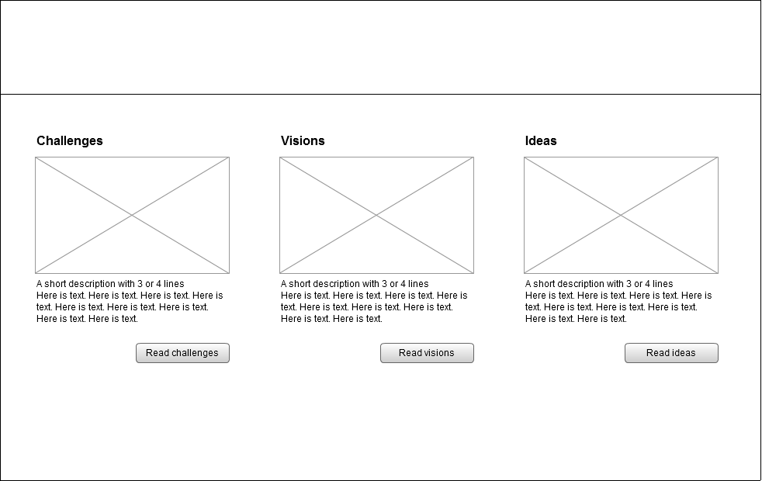

This approach enables the user to have a quick overview over all sections at the same time and start composing their own content right away. Unfortunately, there is not much space for each section and the description text.

#### **Option 2: Accordion**

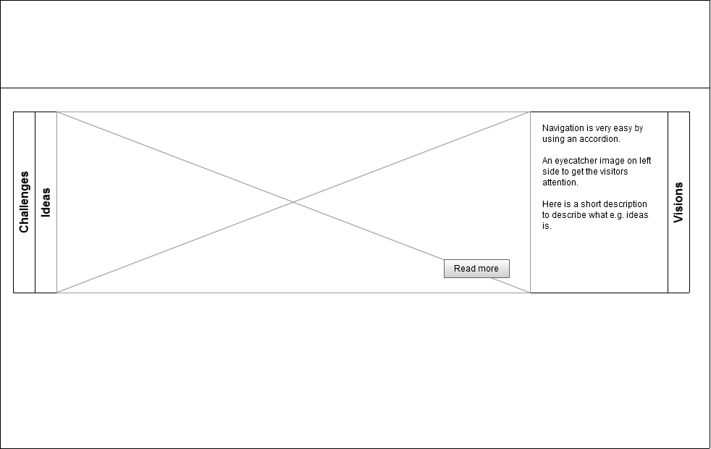

While the user is presented with all sections, he is only able to view one of the categories at the same time. In return, there is much more space to view a picture and description. In addition, the accordion could also slide through automatically.

#### **Option 3: Slider**

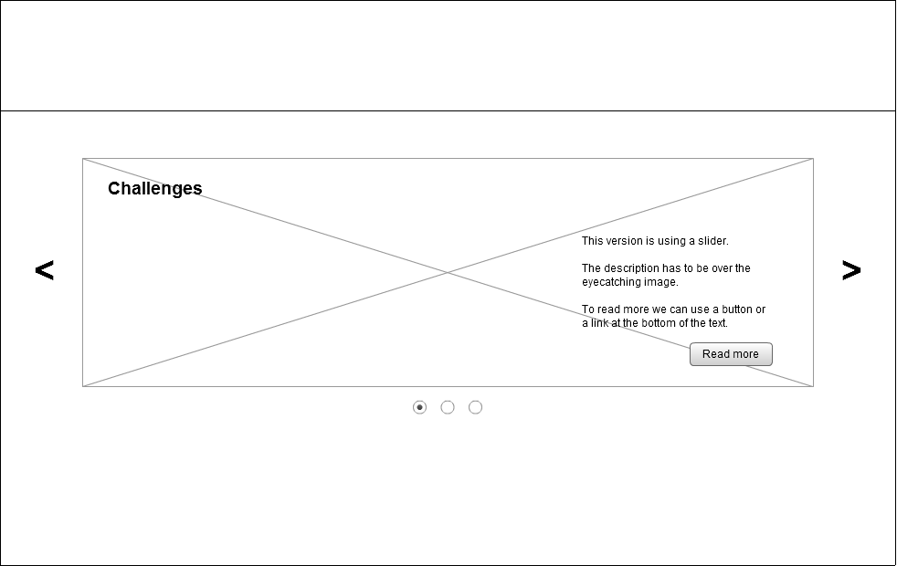

A different approach of using the whole space for displaying a single section is the content slider. Compared to the accordion, the user has no overview over all sections. However, nice animations and automatic sliding raise interest.

#### **Option 4: One below the other**

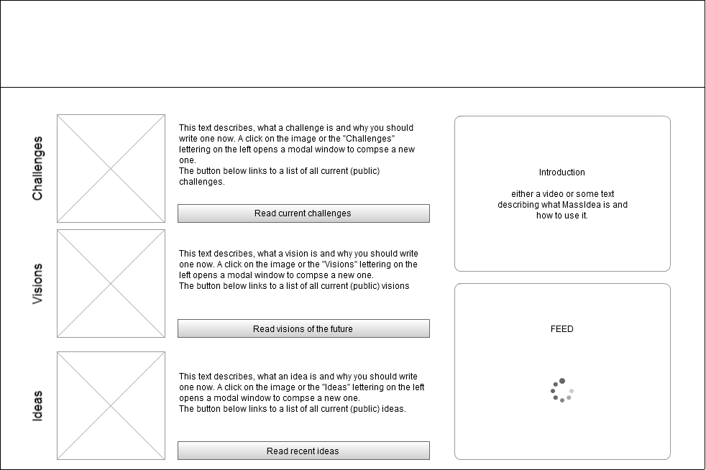

Another option is to place one section below the other and fill eventual space aside with other elements, like the introduction or a live ticker/feed.

## Live Feed

### Functional Description

The live feed shows real contents of the platform. It updates automatically every few seconds to show movement and create interest. Our eyes are focused on changes, so the live feed is a good possibility to catch someone’s attention. The user needs to feel that the website lives.

There are three options:

* show a random content
* show the most recent content
* show a list of projects and groups which are looking for interested people

### Design Concepts

The design concepts below either show many posts or much and detailed information at once.

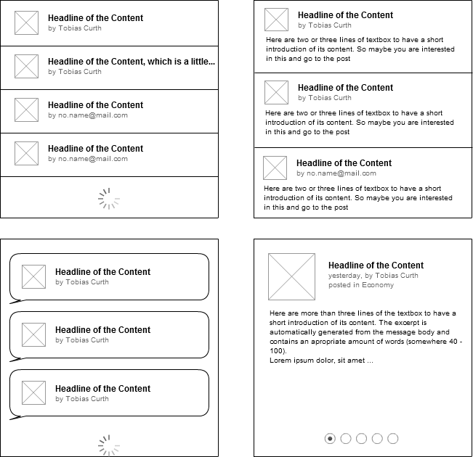

Depending on how much information should be shown, one of those layouts will be the most appropriate for the start page.

## Introduction

### Functional Description

* Short description of the functionalities and vision of MassIdea.
* Video (Tutorial)

If people want to know more about MassIdea, they have the possibility to get a deeper insight into the platform by clicking through a tutorial, reading a description or watching a short and fascinating animation.

## Featured Post

### Functional Description

This part should attract people and motivate them to create their own content which might probably become successful in future. Posts get featured automatically, chosen from the best rated content or content with the most views.

The title of the topic, a short excerpt and an image are shown. If language preferences are set, only content in the preferred language is shown. By clicking on the image or the text, the user is redirected to the content page displaying the full content.

### Design Concepts

#### **One single featured item**

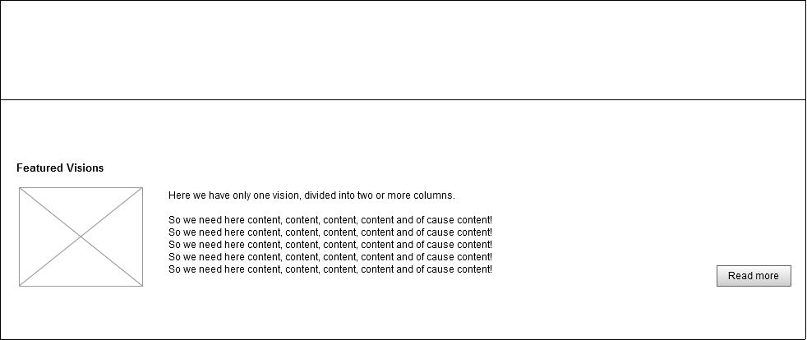

#### **Multiple featured items**

When more than one items are shown, they are arranged in a slider which automatically changes every few seconds.

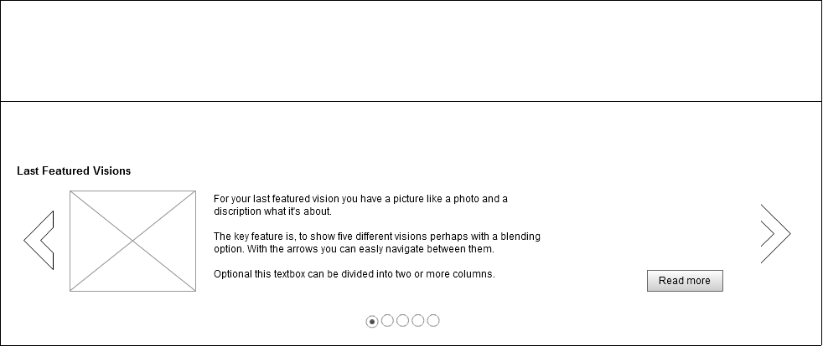

## Project and Groups looking for new people

### Functional Description

##### This part of the website shows

* a random list
* the most recent
* a categorized list

of up to 10 project which are looking for new people in order to attract potential users to join the community and to post new content in a project. Additionally, this enables project members to focus on working for their projects while all personnel needs are fulfilled.

### Design Concepts

The design is similar to the live feed, as almost the same information is shown.

## Footer

### Functional Description

The page footer is displayed on every page of the platform and contains links to the imprint, disclaimer and about-us-page. Additionally, users have the opportunity to choose the language for their user interface. Note that the language of displayed content is set separately for each section.

### Design Concepts

Two separate designs for the language selection either enable the user to change the language quickly by choosing from a select box or by opening a modal dialog window and choosing from a list:

#### **Option 1: Language selection directly in the footer**

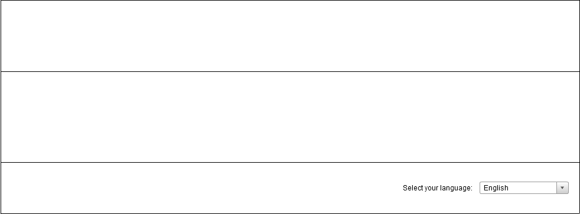

#### **Option 2: Language selection in a modal dialog**

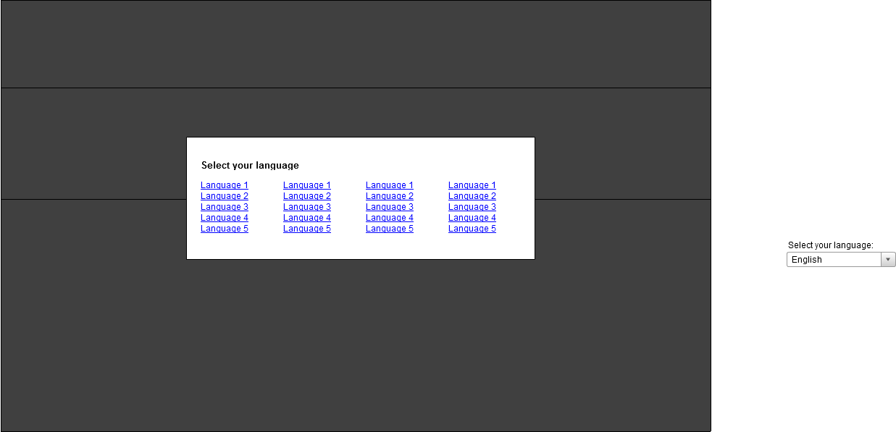

## Creating new content

### Functional Description

This form is equal for creating a new challenge, vision or idea. However, registered users can choose from more options and are presented with more input fields.

Guests can post new content with minimal work, because they have to enter required fields only. Before their content goes online, they first have to do a quick sign up. After signing up, the content is public immediately. The user then has the option to change the settings of the content.

|  |  |  |
| --- | --- | --- |
|  | Guest | User |
| Language  The language of the content is preselected according to the browser language(guest) or the language of the user, which he has selected in his profile. | ✓ | ✓ |
| Header  The header is the title of the content. | ✓ | ✓ |
| Category  The user can choose a category, which fits to his content. | ✓ | ✓ |
| Text Body  This includes the actual content. | ✓ | ✓ |
| Keyword  The user can write keywords according to their content. | 🗶 | ✓ |
| References  The user is able to enter references, which belong to his content. | 🗶 | ✓ |
| Upload File  The user can attach multiple files to describe the content in more detail. | 🗶 | ✓ |
| Visibility  You can choose between public and private. Everyone can see a public content, whereas a private content is only visible for the group or project the content is linked. | 🗶 | ✓ |

### Design Concepts

As creating new content requires much space on the page, the only rational way to display the whole form to the user is in a modal dialog window:

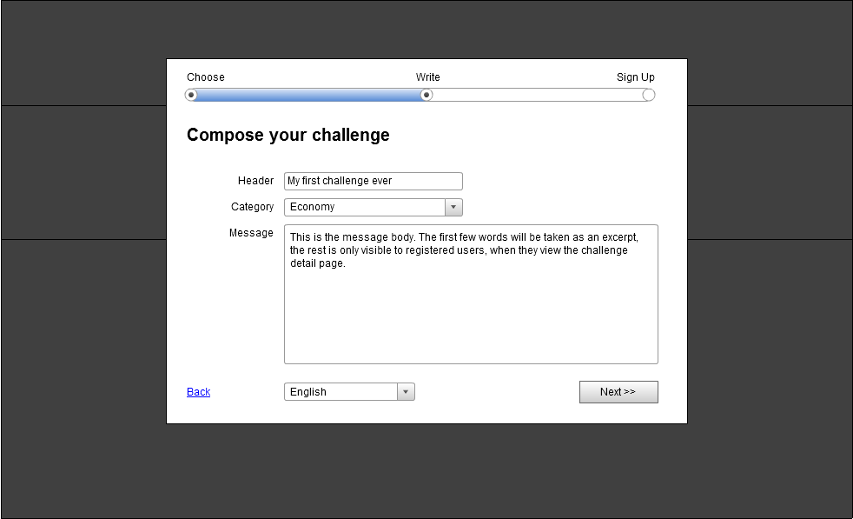

# Main page

## Introduction

The main page is shown for registered users after they log in. It is primarily focused on displaying the preferred content. The preferences can be chosen by setting different filters.

The continuous sidebar, which is displayed on almost all pages, offers the user every possibility the platform offers. Header and footer remain the same as on the start page but with one difference: Instead of the login form a user menu is shown.

## Linked pages:

* Create new content form
* Create new group/project form
* Profile Page/ Profile Settings Page/Messages Page
* Logout -> Start page
* Group Page
* Project Page
* Content List Page
* Content Page

## Header

### Functional Description

#### **Logo**

As soon as the user has logged in, the logo always refers to main page instead of the start page.

#### **Profile Information**

* Shows an image of the user
* Profile Name – the profile name refers to the personal profile.
* In addition you have different options:
  + Log out (refers to the start page)
  + View Profile (refers to the profile page)
  + Profile Settings (refers to the profile settings page)
  + Messages (refers to the private messages page)

### Design Concepts

#### **Option 1: Dropdown menus**

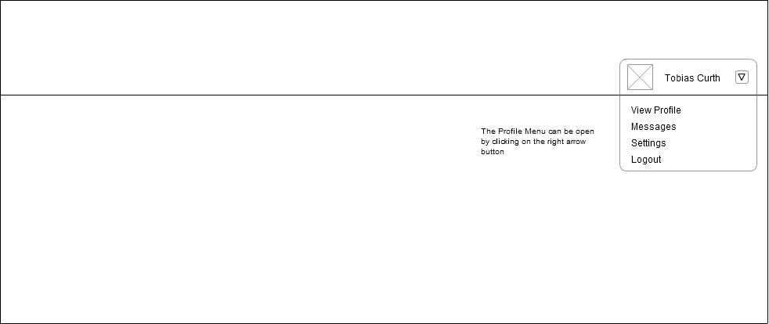 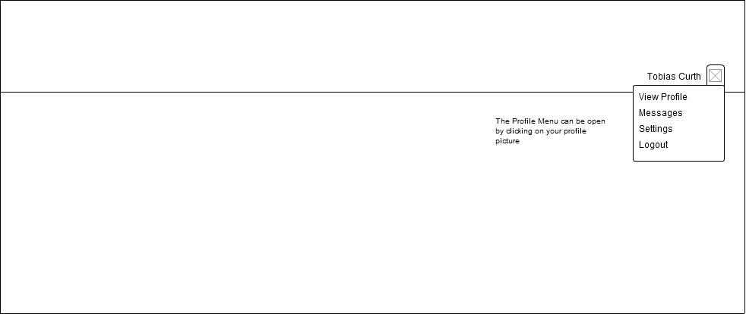

#### **Option 2: Callout box**

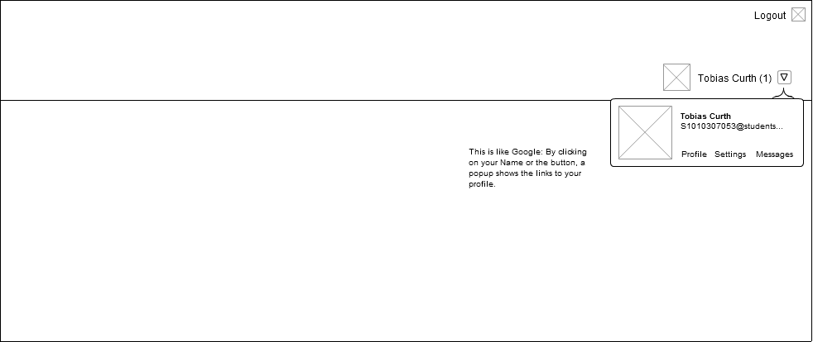

#### **Option 3: Sidebar**

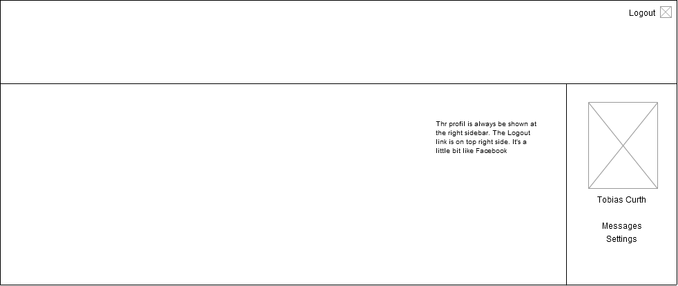

## Create new content/group/project

### Functional Description

Users can create a new content (challenge, idea, vision) – which brings up the “create new content”-form. In addition, they can also create new groups and projects.

When users click on the “create new content” button, they have to decide which type content they want to create, then the “create new content” form appears. When they click on the “create new project/group” button, they are given the additional choice whether the group/project is public or private before the form appears.

The advantage of this alternative is that users have a good overview over the page. They don’t have to adjust to different pages. Another alternative would be to provide only one “create new content” button and display controls to create groups and projects on the appropriate subpages only.

### Design Concepts

#### **Option 1: Separate buttons above the feed**

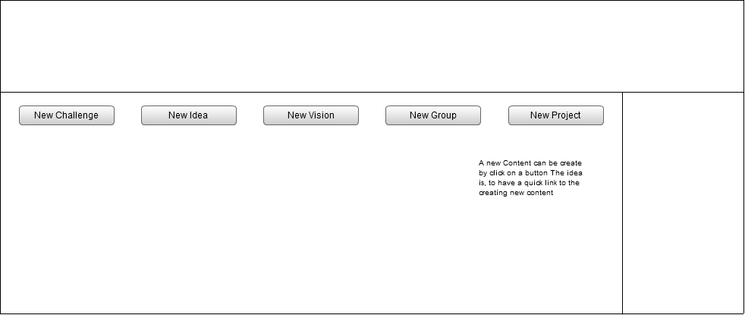

#### **Option 2: Dropdown toggles above top right**

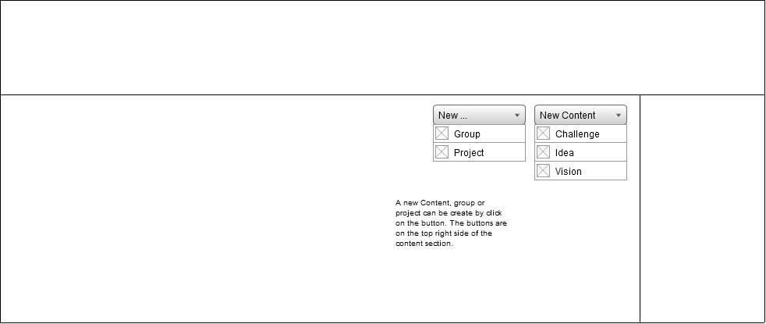

## Create new content form

### Functional Description

For a detailed functional description, look at the “Create new content” section of the start page.

### Design Concepts

#### **Option 1: Horizonal form with lables aside**

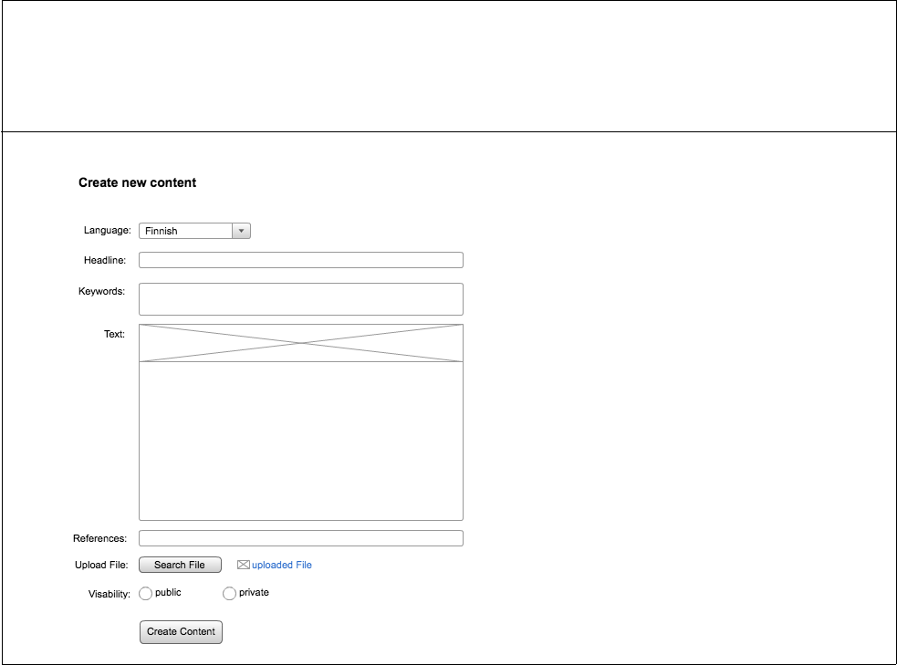

#### **Option 2: Horizonal form with lables above**

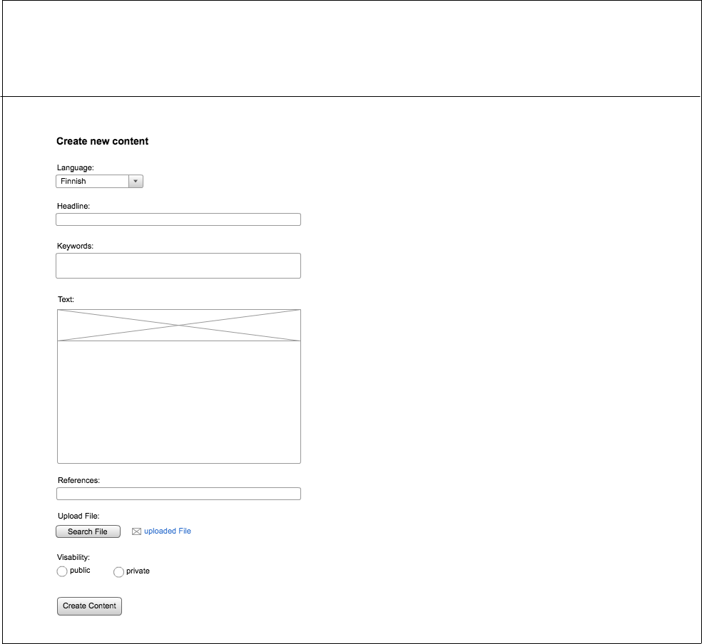

#### **Option 3: Accordion style form**

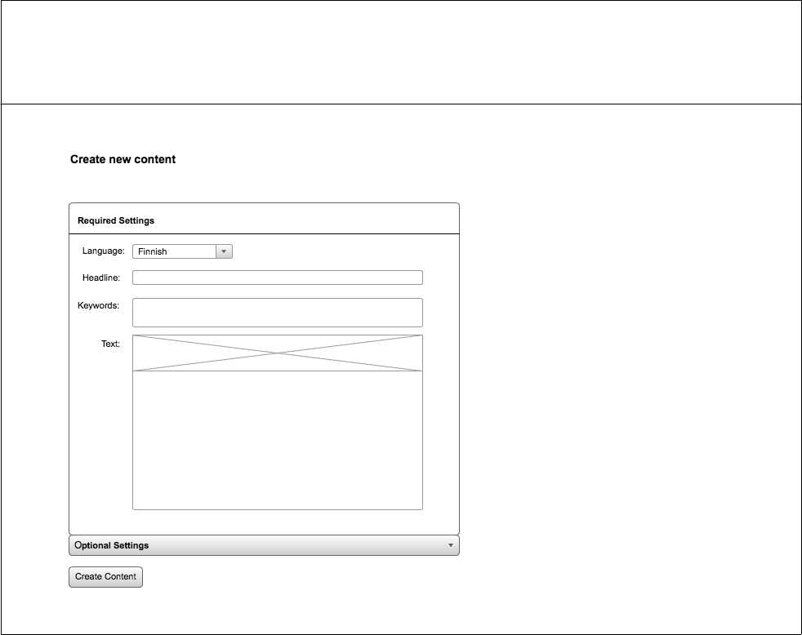

#### **Option 4: Tab based complexity reduction**

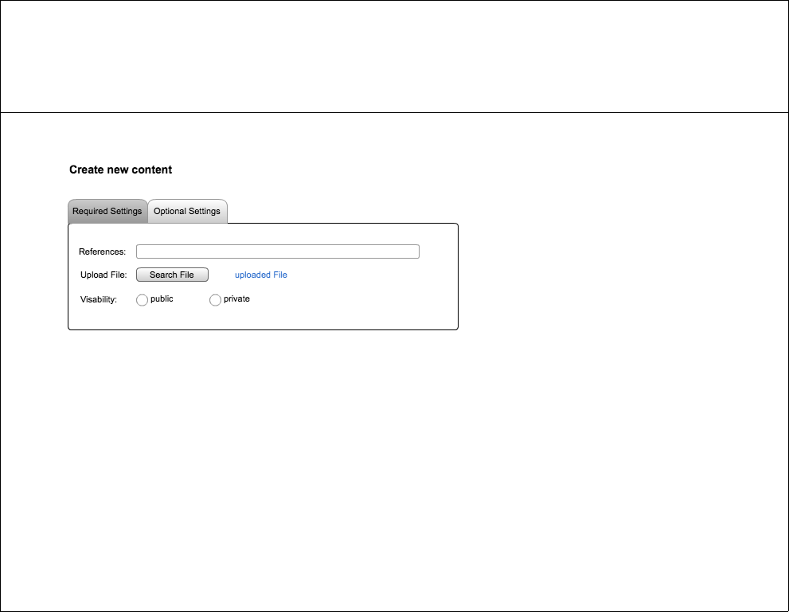

## Sidebar

### Functional Description

The sidebar is divided into different parts:

**Search**Users can search for content with special keywords, so they can easily find content they are interested in.

**Content-Filter**There are several filters (show all contents, show only ideas, show only visions, show only challenges, show only groups, show only projects). Users are able to choose between public content and private content. Private means that only content the user is related to is shown. Public means, all global content – applying to the other filters – is shown.

**Projects**Users can see a list of 5 projects you interact the most. You have the opportunity to list all projects you’re involved in.

**Groups**Users can see a list of 5 groups you interact the most. You have the opportunity to list all groups you’re involved in.

The sidebar is a good opportunity for users to get an overview of the content you prefer. Moreover, the user keeps a good overview over the whole system.

### Design Concepts

#### **Option 1: Sidebar containing search right, filters top**

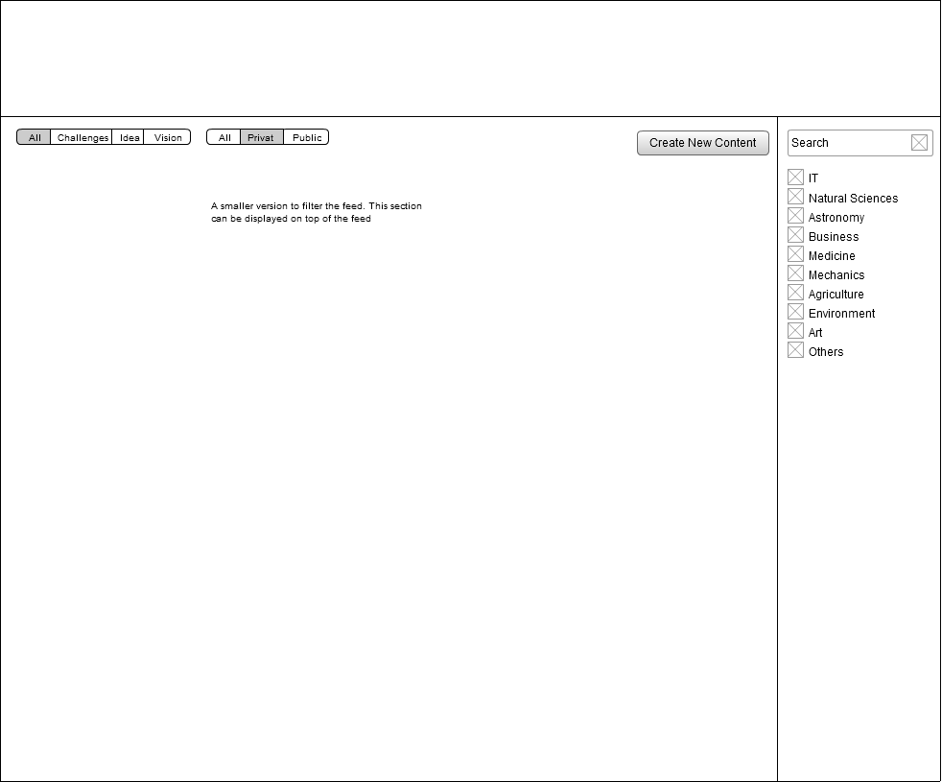

#### **Option 2: Sidebar on the left, containing all filters and links**

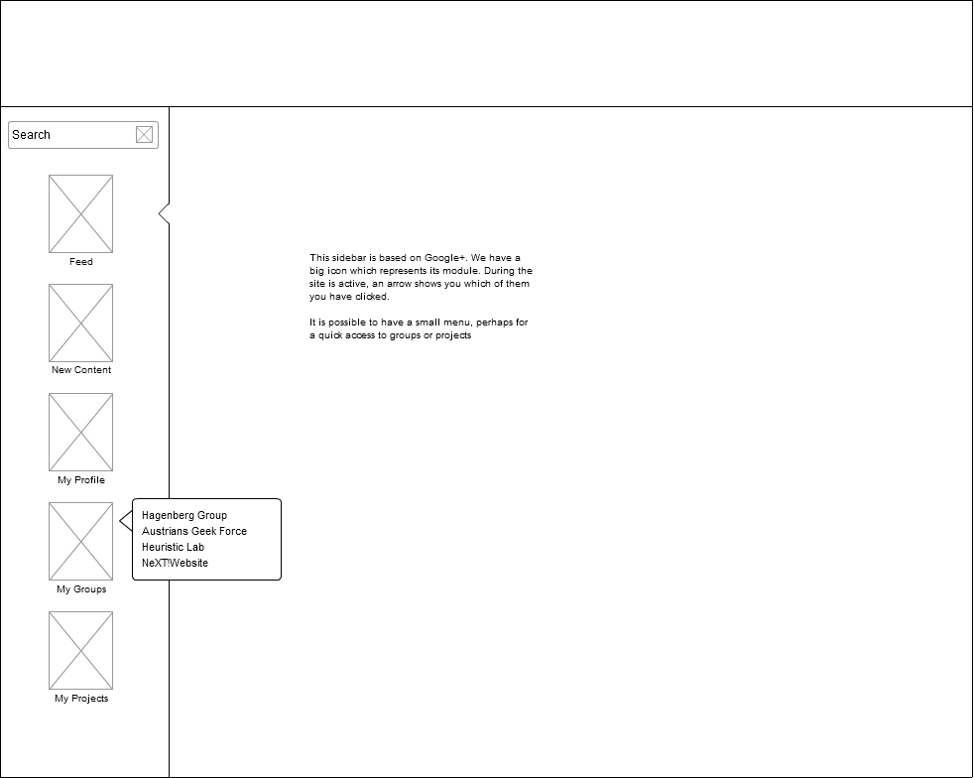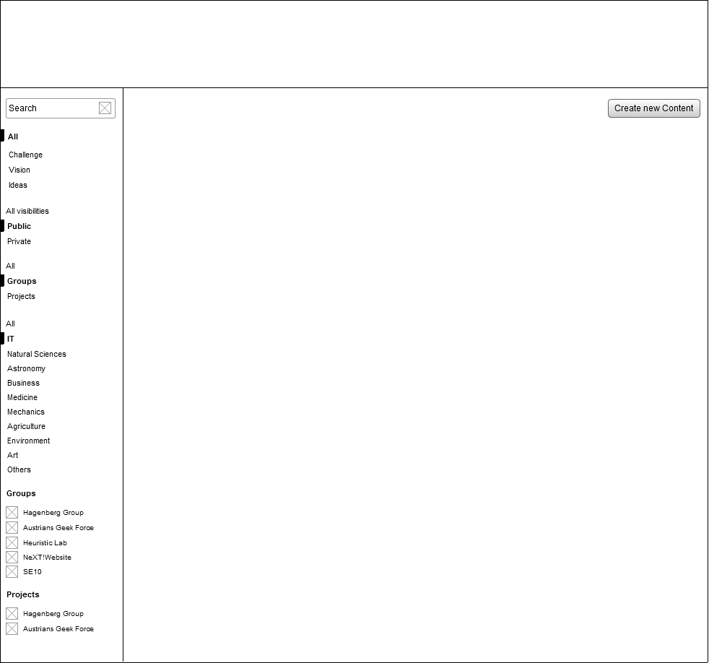

The right design shows a Google-Plus like approach with huge images and hover descriptions.

## Feed

### Functional Description

According to the selection of the sidebar, the content is listed in the feed. The several contents are shown with an image and the beginning of the content text (40 words). If you want to read the whole content, just click on it.

The listed content in the feed can be filtered in language and fixed categories. The advantage of additional filters is that the shown content can be limited to everyone’s preferences for better overview.

**Categories**

1. IT
2. Natural sciences
3. Astronomy
4. Business
5. Medicine
6. Mechanics (automation engineering)
7. Agriculture
8. Environment
9. Art
10. Others

**Footer** is the same as the footer on the start page.

### Design Concepts

#### Option 1: The feed with 5 star rating

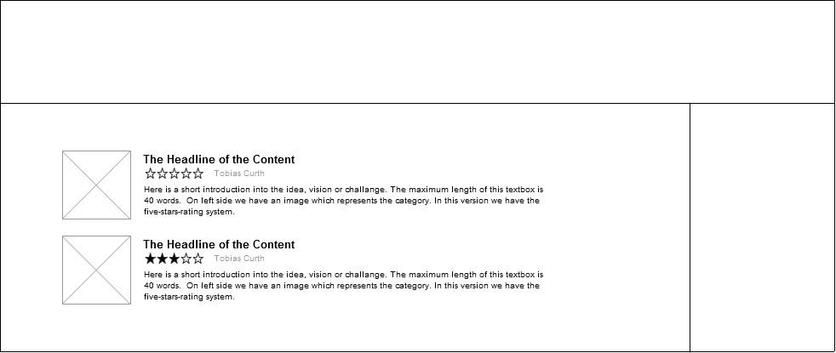

The wireframe shows a five star rating. For more detailed information about rating systems see next chapter.

# Content Page

## Introduction

The content page shows the entire content of a single post. All fields which have been entered are listed. Users have the possibility to link their own content, make comments or rate the quality of the content.

Additionally, users are able to follow related links to other posts or topics. On the very bottom of the page, users can post comments to discuss the topic, give feedback or give suggestions.

## Linked pages:

* Create new content form
* Profile Page/ Profile Settings Page/Messages Page
* Logout -> Start page
* Group Page
* Project Page
* Content List Page (the whole content is listed of either a challenge, idea or vision)

## Design Concepts

Depending on how much information has to be displayed, one of the following layouts is the suitable option for showing detailed contents to the user.

#### **Option** 1: Horizontal layout with a lot of white space

Especially when a lot of information is displayed, white space is an important part of the page as it loosens up the layout and prevents it from looking crowded. Since more and more users are adopting large screens, almost every modern web page tends to have rather much white space on their pages.

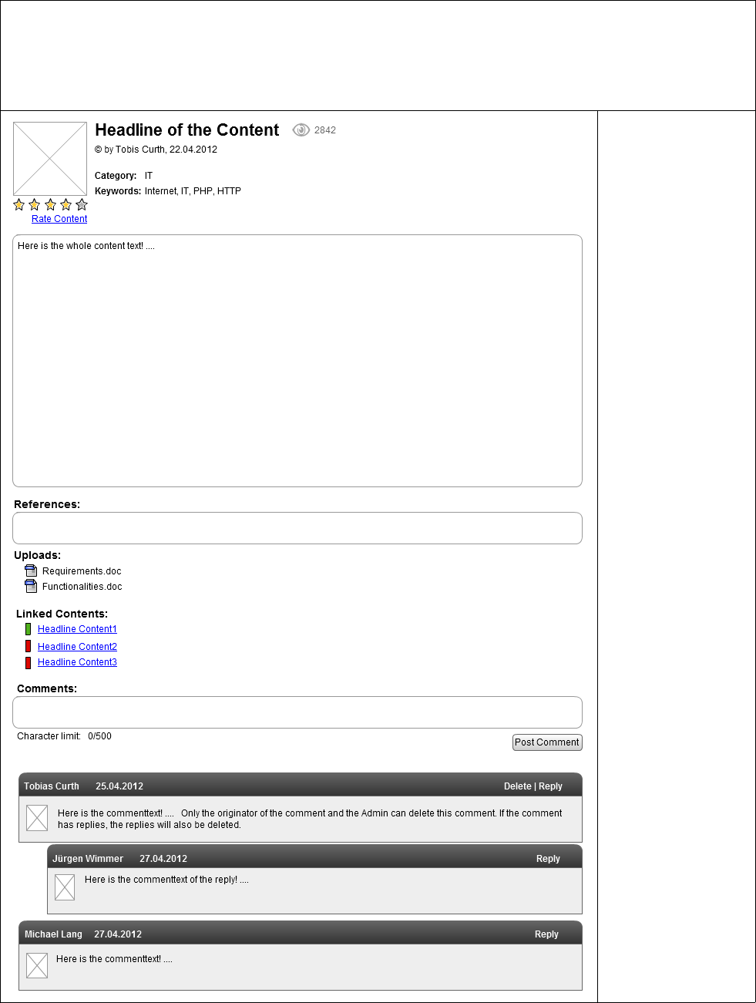

#### **Option** 2: Condensed layout with vertically arranged elements

A drawback of much white space is that it is almost impossible to get an overview over the whole content on smaller screens. Thus, a condensed approach which arranges most of the elements side by side addresses this issue.

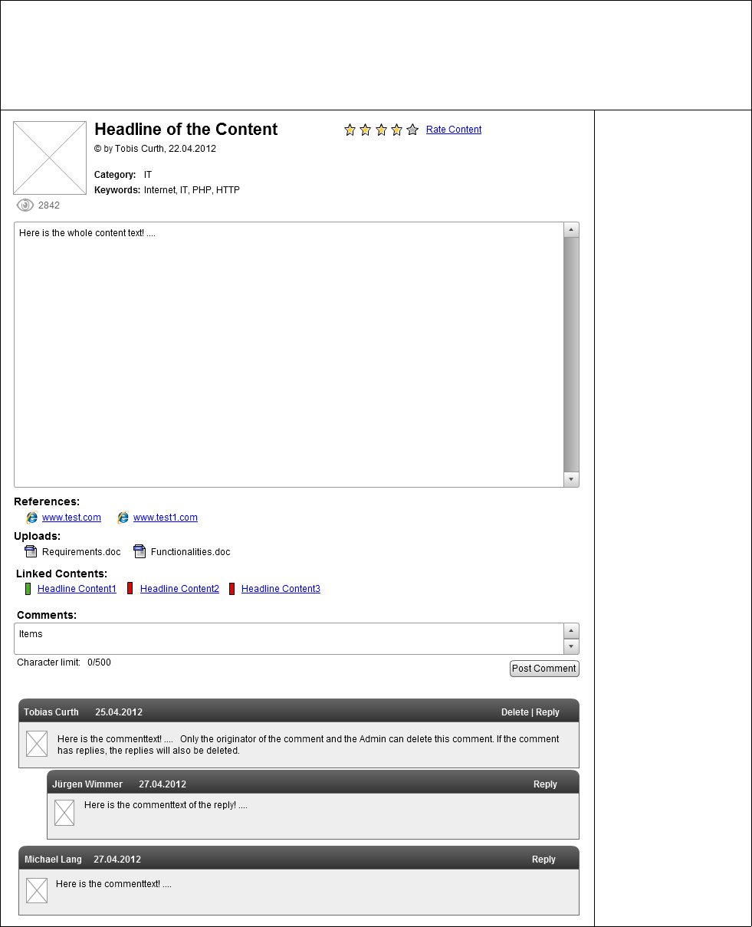

## Rating

### Functional Description

There are two options to rate the content.

#### **Option 1: Like and dislike**

Users can choose between **Like** and **Dislike**. This is a very easy decision for an average user, so people will more likely rate content. The drawback of this option is that there is no difference between “I like the content because it’s a good idea” and “I like the content because the description is good”.

#### **Option 2: 5 star rating**

**While users might be able to express their opinions a little bit better compared to the like and dislike approach, it is harder to come to a conclusion before committing the rating. This might prevent some users from actually rating content.**

### Design Concepts

#### **Option** 1: Like and dislike

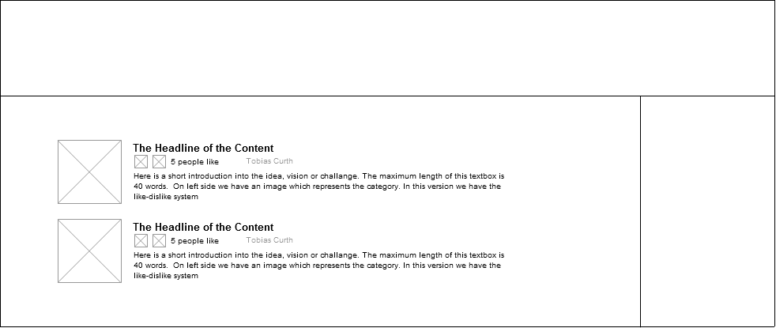

#### **Option 2: 5 star rating**



# Profile/ Profile Settings / Private Messages

To keep a continuous layout the sidebar is also displayed on the profile page. By changing the links of the sidebar, users can navigate much better through their profile page, but the connection to the contents will be lost.

## Profile

Users are able to see the profile image. Moreover they can see the personal details the user has entered. In addition they can see the history of the user’s activities (created contents, joined groups and contents). The history is sorted by date.

There is an additional rating which is the average of the rating of the user’s contents. In addition to this, there will be a counter of the contents the users has created.

Profile Settings

Users can see the entered information and are able to change them. Moreover they can choose whether the rating or the counter is displayed on the profile page or not.

## Private Messages

Users are able write a message to another user. The messages are grouped to conversations which are shown in a conversation list. Users are able to delete conversations. When receiving a message, users get a notification.

Note that design concepts for this and all subsequent sections have not been completed yet. They will be created and included in near future.

# Create Group form

## Introduction

A new group is created when users want to find others with the same interest.

### Functional Description

Users can create a new group by entering the following information:

|  |  |  |
| --- | --- | --- |
| Field | Required | Description |
| Name | ✓ | Enter a Title of the group |
| Category | ✓ | Select a category |
| Description | ✓ | Enter the description of the group |
| Image | 🗶 | Upload an image |
| Visibility | 🗶 | Default: public Select between public and private. |

Visibility of the Group

Users can join a public group without special permissions, whereas users who want to join a private group have to send a request to the group admin in order to receive confirmation first.

# Group Page

## Introduction

To keep a continuous layout the sidebar is also displayed on the group page. By changing the links of the sidebar, users can navigate much better through the group page, but the connection to the contents will be lost.

### Functional Description

Users are able to view all members of this group. In addition they can also invite other users by sending them invitation messages.

Besides a name, every group has its own image and description, which is displayed on the group page. Below that, a history of all posts in this group helps users to look back into the past. This history is sorted by date. New users can see the most actual contents and have a perfect overview over all activities of other team members.

Another possibility is to divide the content into ideas, challenges and visions. Users can easily distinguish between different post types but probably lack an overview soon. By achieving such a division with filters on the history, however, the advantages of both approaches are combined with maximal flexibility.

# Create Project form

## Introduction

A new project is created when someone has a clear aim and wants to solve it together with other users.

### Functional Description

Users can create a new project by entering following fields:

|  |  |  |
| --- | --- | --- |
| Field | Required | Description |
| Name | ✓ | Enter a Title of the group |
| Category | ✓ | Select a category |
| Description | ✓ | Enter the description of the group |
| Image | 🗶 | Upload an image |
| Visibility | 🗶 | Default: public Select between public and private. |
| Start Date |  | Default: create date of the project |
| End Date |  | Default: open end |
| Project status |  | Enter a project status which fits to the current situation |
| Searching for people |  | Default: “no”, choose between “yes”, “no” |

# Project Page

## Introduction

The project page is similar to the group page. The difference between groups and projects is that projects are dynamic and have tasks and a clear aim. Moreover, projects can be tagged as active, inactive and completed. In contrast to groups, team members in projects change more often because different project phases need different people.

### Functional Description

Despite the semantic differences, groups and projects have the same functions. To simplify adding new people and emphasize the dynamic aspects of projects, however, some user interface elements will receive a redesign or rearrange.

# Privacy

## Introduction

Users can choose between two privacy levels: public and private. So users have the possibility to show their contents only selected people. Additionally they have the option to make groups and projects public or private. This means that users, which want to join a private group or project, first have to send a join request to the group admin, to see the content of it.

### Functional Description

## Content

### Public: A public content is visible for everyone.

**Private**: A private content is only visible for the user.

## Group / Project

**Public:**  The content of a public group/project is visible for everyone, but only team members have the rights to invite others, make comments or link content.

**Private**: The content of a private group/project is only visible for team members.

Linking   
Users are able to link their contents to another content, project or group.

Additionally, users who want to link private content to a public content/group/project get a notification that the content is now visible for a greater number of people. The link will not be bidirectional. This means that the link is only visible for the content of the linker. The originator gets a message that his content has been linked and can decide whether he wants the other content linked with his content.

|  |  |  |  |  |
| --- | --- | --- | --- | --- |
|  | Private C. | Public C. | Private Group/Project | Public Group/Project |
| Link Private Content to | - | 🢭 | 🗶 | 🢭 |
| Link Public Content to | - | ✓ | ✓ | ✓ |

✓ Everyone  
🗶 Group/Project members  
🢭 Visitors

When users link private content to public content the private content is visible for all users, who read the public content. When users link private content to a public group or project the content is visible for all viewers of this group or project.

# Other useful aspects

## Text-Fields

Generally all description fields of contents/groups/projects can be formatted.

## Comments

Generally users can make comments on all contents they are allowed to see and all groups/projects they have joined. Furthermore users are able to reply to a comment. Additionally the originator of the comment can delete his comment. If the comment has replies, these replies will also be deleted.

## Administration

The system admin can edit/create/delete/read all content/group/projects/users/comments.

## Group/Project Admin

The admin can edit the team-member list (remove a user from the group/project), edit/delete links/group information and delete comments in the group.